QUEEN GREATEST HITS TO BE RE-RELEASED ON VINYL NOVEMBER 18

First time available worldwide as gatefold-sleeve double vinyl album

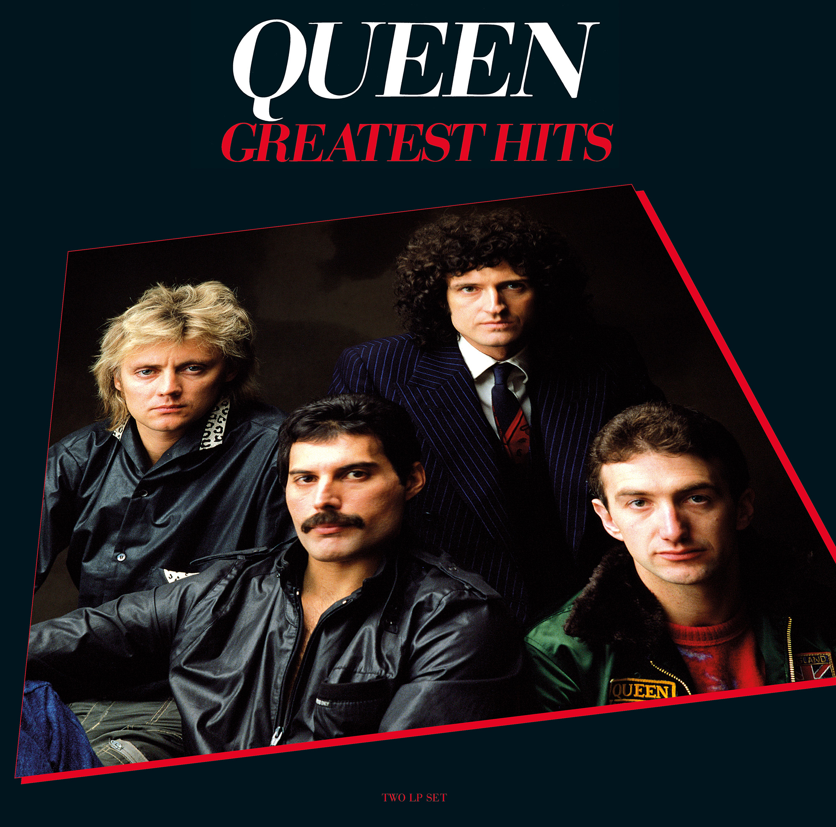

Reissued on vinyl on November 18 on Hollywood Records and Virgin EMI (outside North America), Queen’s best-selling compilation Greatest Hits throw fresh light on an unrivalled track record of chart-topping, award-winning, record-breaking rock and pop classics. With four songwriters in the band - Freddie Mercury, Brian May, Roger Taylor and John Deacon - Queen created a glorious legacy of all-time anthems that still ring out across the ages. For past and future fans alike, they will rock you.

First released in 1981, Greatest Hits is certified 8x Platinum in the U.S., counts global sales in excess of 25 million and is the best-selling album of all time in Britain, standing alone as the first and only album to have sold over 6 million copies in the UK (6.1 million sales to date). And to date, the tracks on Greatest Hits combined have garnered over 646 million Spotify streams globally.

Newly re-mastered as a gatefold-sleeve double vinyl album for the first time worldwide, these 17 tracks are now spread across four sides of 180 gram heavyweight vinyl, enriching the audio quality of a band rightly celebrated for their multi-tracked studio perfectionism. Deep, warm and luxuriant, this is exactly how Queen should sound.

Spanning Queen's triumphant first act, from 1974 to 1980, Greatest Hits includes some of the world's most beloved rock standards, including the stadium-sized symphonic chart-topper “Bohemian Rhapsody” and the roof-raising “We Are The Champions,” which was named the most catchy song of all time by a team of scientists in 2011. But this album also dazzles with its stylistically promiscuous range, from the crowd rousing “We Will Rock You,” the tongue in cheek “Fat Bottomed Girls,” the stomp-stomp-stomp late 70’s disco inspired “Another One Bites the Dust,” to the finger-snapping jukebox retro-rock homage “Crazy Little Thing Called Love” and the soaring, impassioned, gospel-fired Aretha-isms of “Somebody To Love.” Sublime songwriting genius.

Undimmed by time or fashion, Greatest Hits is a welcome reminder that Queen were always colorful, always dynamic, always ablaze with passion and pride. They filled the heavens with a musical rainbow.

Greatest Hits
2xLP gatefold – 180 gram heavyweight vinyl – includes MP3 download voucher
Hollywood Records (North America)
Virgin EMI (outside North America)

TRACKLISTING
SIDE A
1. Bohemian Rhapsody
2 Another One Bites The Dust
3. Killer Queen
4. Fat Bottomed Girls

SIDE B
1. Bicycle Race
2. You’re My Best Friend
3. Don’t Stop Me Now
4. Save Me

SIDE C
1. Crazy Little Thing Called Love
2. Somebody To Love
3. Now I’m Here
4. Good Old Fashioned Lover Boy

SIDE D
1. Play The Game
2 Flash
3. Seven Seas Of Rhye
4. We Will Rock You
5. We Are The Champions

# # #

TWITTER │ FACEBOOK │ YOUTUBE │ WEBSITE

U.S PRESS CONTACT:
Sharrin Summers // Hollywood Records // sharrin.summers@disney.com

