PUBLICITY

SABRINA CARPENTER ANNOUNCES OCTOBER 14th RELEASE DATE FOR HIGHLY ANTICIPATED SOPHOMORE ALBUM EVOLution

THE EVOLution 2016 TOUR, CARPENTER’S FIRST-EVER NORTH AMERICAN HEADLINING TOUR, KICKS OFF OCTOBER 18 IN NASHVILLE
WATCH TOUR TEASER HERE

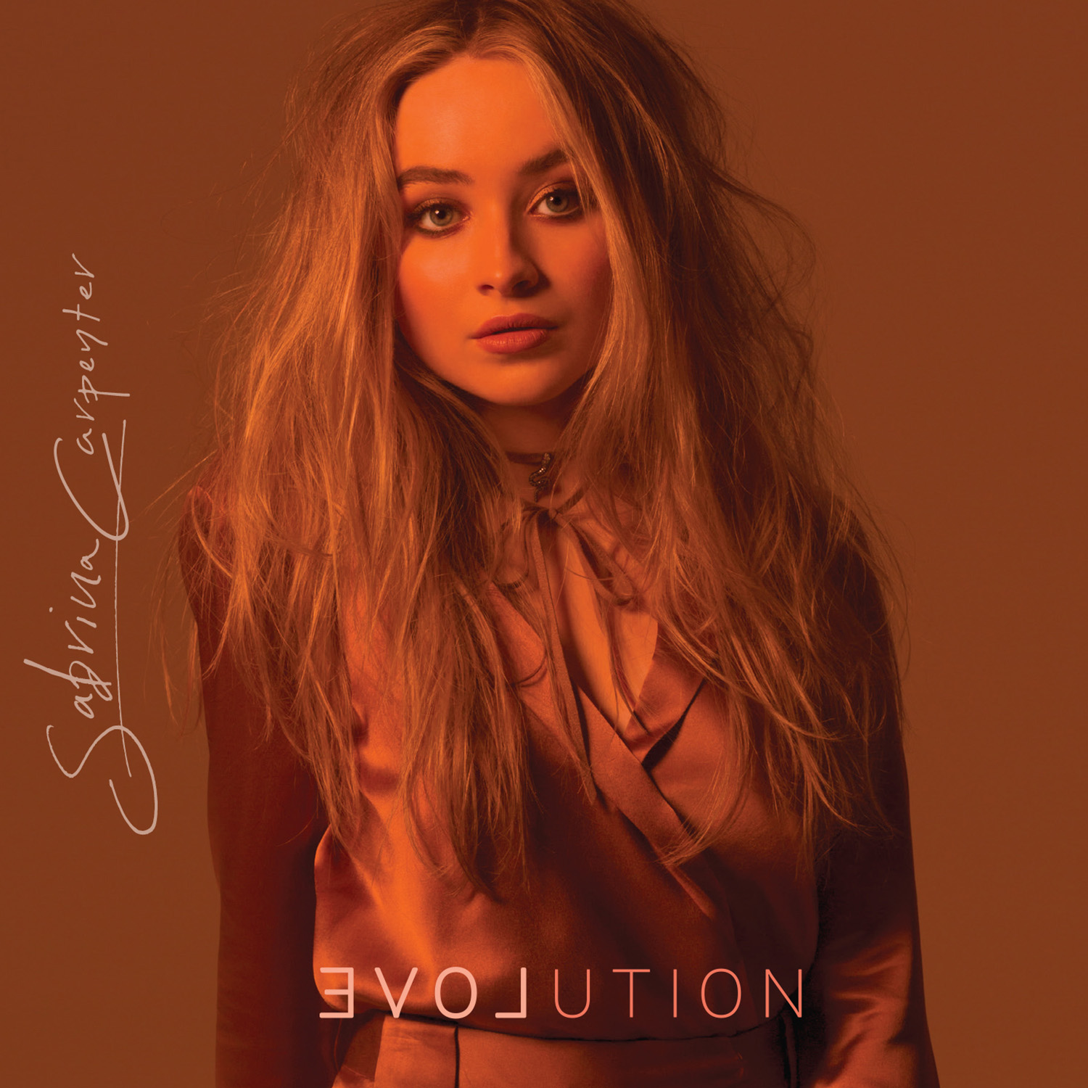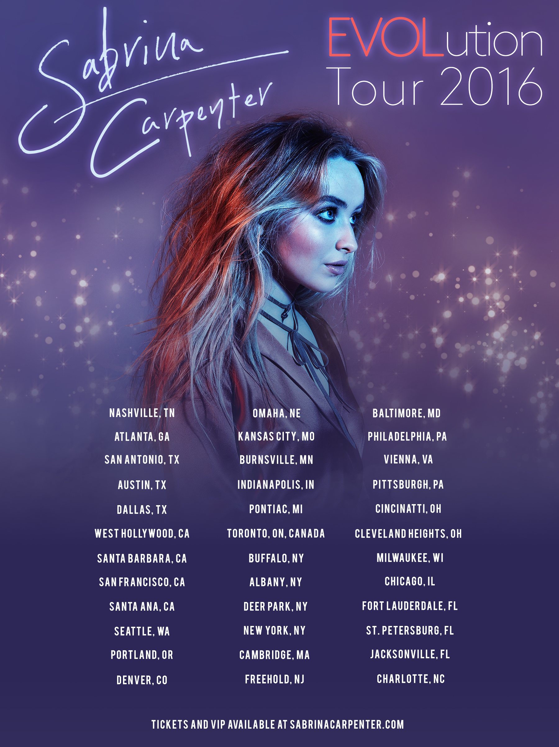

TICKET PRESALE BEGINS SEPTEMBER 8TH AT 10AM LOCAL TIME
GENERAL PUBLIC ON-SALE STARTS SEPTEMBER 9TH AT 5PM LOCAL TIME

ALBUM PRE-ORDER BEGINS FRIDAY, SEPTEMBER 23 AT ALL DIGITAL PLATFORMS

(September 6, 2016) – Singer/songwriter and actress Sabrina Carpenter has announced the October 14th release date of her sophomore album, EVOLution, and a major North American headlining tour of the same name kicking off October 18th in Nashville, TN. Having co-written the majority of EVOLution and launching her first-ever cross country headlining tour, the album and tour mark a momentous step in Carpenter’s career.

“Art produces emotion. Emotion produces change. Change produces evolution. And evolution is what life is all about,” explains Carpenter on the significance of the title.

Due out October 14 worldwide, the compelling 10-track EVOLution album is available for general public pre-order beginning Friday, September 23 at all digital platforms.

The 35 date North American EVOLution 2016 Tour will bring Sabrina Carpenter’s live show to just about every corner of the U.S. and into Canada. The tour kicks off October 18 in Nashville, TN, at Rocketown and will include stops in Atlanta, Austin, Dallas, Chicago, Los Angeles, Toronto, Philly and New York.

Tickets for the EVOLution 2016 Tour will go on sale to the general public starting September 9th at 5p.m. local time. VIP packages will be available through VIP Nation. For more information, please visit VIPNation.com.

Sabrina Carpenter’s EVOLution 2016 Tour Dates as follows:
Date | City | Venue
Oct. 18 | Nashville, TN | Rocketown | SOLD OUT
Oct. 20 | Atlanta, GA | The Loft | SOLD OUT
Oct. 22 | San Antonio, TX | Studio Theater at The Tobin Center | SOLD OUT
Oct. 23 | Austin, TX | 3Ten | SOLD OUT
Oct. 24 | Dallas, TX | Trees | SOLD OUT
Oct. 27 | West Hollywood, CA | The Roxy | SOLD OUT
Oct. 29 | Santa Barbara, CA | Lobero Theatre | SOLD OUT
Oct. 30 | San Francisco, CA | Slim’s | SOLD OUT
Nov. 1 | Santa Ana, CA | Constellation Room | SOLD OUT
Nov. 3 | Seattle, WA | Neumo’s | SOLD OUT
Nov. 5 | Portland, OR | Hawthorne Theatre | SOLD OUT
Nov. 7 | Denver, CO | Bluebird Theatre | SOLD OUT
Nov. 8 | Omaha, NE | Slowdown
Nov. 10 | Kansas City, MO | Record Bar
Nov. 11 | Burnsville, MN | The Garage | SOLD OUT
Nov. 13 | Indianapolis, IN | Deluxe at Old National Center
Nov. 14 | Pontiac, MI | Pike Room | SOLD OUT
Nov. 16 | Toronto, ON | Mod Club | SOLD OUT
Nov. 17 | Buffalo, NY | Buffalo Iron Works
Nov. 18 | Albany, NY | The Hollow | SOLD OUT
Nov. 19 | Deer Park, NY | Tanger Outlets at The Arches | SOLD OUT
Nov. 21 | New York, NY | Highline Ballroom | SOLD OUT
Nov. 23 | Cambridge, MA | The Sinclair | SOLD OUT
Nov. 25 | Freehold, NJ | iPlay America
Nov. 26 | Baltimore, MD | Sound Stage Baltimore | SOLD OUT
Nov. 27 | Philadelphia, PA | The Foundry at The Fillmore | SOLD OUT
Nov. 29 | Vienna, VA | Jammin Java | SOLD OUT
Nov. 30 | Pittsburgh, PA | Stage AE | SOLD OUT
Dec. 2 | Cincinnati, OH | 20th Century Theatre
Dec. 3 | Cleveland Heights, OH | Grog Shop | SOLD OUT
Dec. 4 | Columbus, OH | A&R Bar | SOLD OUT
Dec. 5 | Milwaukee, WI | Turner Hall Ballroom
Dec. 6 | Chicago, IL | Schubas Tavern | SOLD OUT
Dec. 9 | Fort Lauderdale, FL | Parker Playhouse | SOLD OUT
Dec. 10 | St. Petersburg, FL | State Theatre | SOLD OUT
Dec. 11 | Jacksonville, FL | Jack Rabbits | SOLD OUT
Dec. 13 | Charlotte, NC | McGlohan Theatre at Sprint Square | SOLD OUT

ABOUT SABRINA CARPENTER:
As a warm up to the EVOLution 2016 tour, Sabrina Carpenter achieved a life-long dream by coming home to play for several thousand fans during her main stage headline show at Musikfest in Bethlehem, PA, August 12. She was honored to be among so many incredible headliners during the 10-day festival including The Avett Brothers, Lady Antebellum, and X Ambassadors among others.

Though Carpenter established an intense international fan base by playing rebellious Maya Hart on the popular Girl Meets World, music is where she started and remains her first love. The Los Angeles-based multitalented singer/songwriter, who has played for audiences as far away as China and Australia, released her debut album, Eyes Wide Open in April 2015. The album, which has amassed over 54M+ streams combined on Spotify since its April 14, 2015 is a collection of uplifting, infectious pop songs, many of them co-written by Carpenter. The accompanying music videos for songs including “Can’t Blame a Girl for Trying,” “Middle of Starting Over,” “Eyes Wide Open” and “We’ll Be The Stars” have amassed over 120M combined views and counting. Earlier this year Carpenter released a new song, “Smoke and Fire” for her fans. The track’s video clip has already surpassed 20M+ video views. And to kick off the countdown to her fall album release, Carpenter recently dropped the first track from EVOLution, “On Purpose.” The ethereal video clip, which has racked up over 3M+ views in three weeks, was shot in London and Madrid, can be watched HERE.

“On Purpose”
iTUNES │ AMAZON │ GOOGLE PLAY ⏐ SPOTIFY │ STREAMING

Sabrina Carpenter’s official socials
Official Website │ Facebook │ Instagram │ Twitter │ YouTube | EVOLution Instagram

#EVOLutionTour | #EVOLution

Sabrina Carpenter Media Kit HERE

PRESS CONTACTS:
Brit Reece / PMK
British.Reece@pmkbnc.com

Natasha Desai / PMK
Natasha.Desai@pmkbnc.com

Sharrin Summers / Hollywood Records
Sharrin.Summers@disney.com

