FOR IMMEDIATE RELEASE PUBLICITY
August 12, 2016

SABRINA CARPENTER RELEASES OFFICIAL “ON PURPOSE” VIDEO

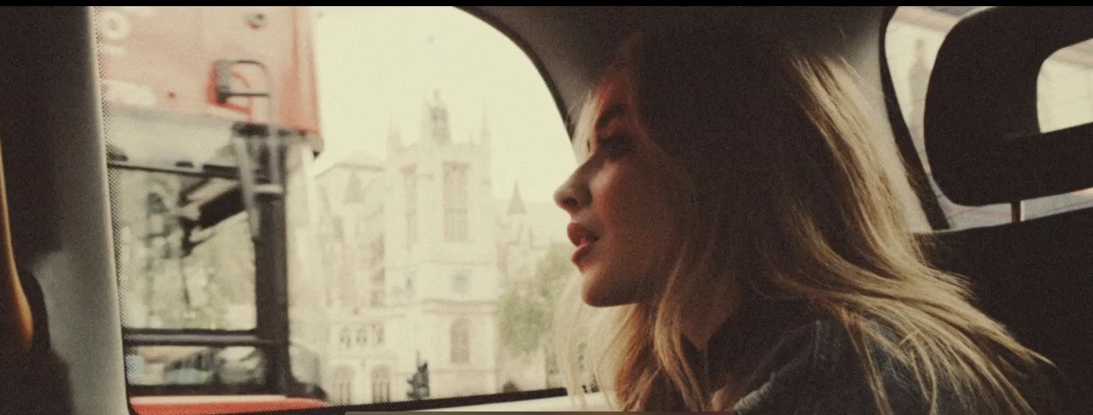

SOPHOMORE ALBUM DUE THIS FALL

“On Purpose” official video – SHARE

Singer /songwriter Sabrina Carpenter has released the official music video to her latest track, “On Purpose,” off her upcoming as-yet-to-be-titled album. The idyllic video, directed by James Miller, follows Sabrina over several days and across several countries as she travels the charming streets of London and sun drenched paseos of Madrid making her way through Trafalgar Square, St. James Park, Soho, Templo De Debod and Plaza Santa Ana.

Available at all digital providers HERE and all streaming providers HERE, “On Purpose,” co-written by Carpenter and Ido Zmishlany, is the follow up to “Smoke and Fire,” and is the second teaser track released kicking off the countdown to Sabrina’s sophomore album release this fall.

“I wrote this song with Ido, who I also wrote “Smoke and Fire” with and several other songs that will be on the album. We originally wrote “On Purpose” about never growing up and it slowly evolved into what it is now,” says Sabrina. “It was like a movie that we had in our heads. It truly came together on its own; on purpose.

As a warm up to her fall headline dates, Sabrina is heading home to headline the main stage at Musikfest in Bethlehem, PA, August 12. Other headliners during the 10-day festival include The Avett Brothers, Lady Antebellum, and X Ambassadors among others. From there, she’ll play “Show of the Summer” on August 20 at Hershey Park Stadium in Hershey, PA, where she’ll share the stage with Shawn Mendes followed by a headlining show at Frontier City in Oklahoma City, OK.

Though she’s established a rabid international fanbase by playing rebellious Maya Hart on the popular Girl Meets World, music remains Sabrina Carpenter’s first love. The Los Angeles-based multitalented singer/songwriter, who has played for audiences as far away as China and Australia, released her debut album, “Eyes Wide Open” in April 2015. The album, which has amassed over 33M streams combined on Spotify since its April 14, 2015 is a collection of uplifting, infectious pop songs, many of them co-written by Carpenter. The accompanying music videos for songs including “Can’t Blame a Girl for Trying,” “Middle of Starting Over,” “Eyes Wide Open” and “We’ll Be The Stars” have amassed over 85M combined views and counting.

“On Purpose”
iTUNES │ AMAZON │ GOOGLE PLAY ⏐ SPOTIFY │ STREAMING

Sabrina Carpenter’s official socials
Official Website │ Facebook │Instagram │ Tumblr │ Twitter │ YouTube

Media Contacts:
Sharrin Summers
Hollywood Records
Sharrin.Summers@Disney.com / 818.560.5787

Lyssa Hurvitz
Hollywood Records
Lyssa.D.Hurvitz.-ND@disney.com / 818.560.7283

