**ZZ WARD AND DELTA RAE TO CO-HEADLINE ‘FIRE AND SHINE’ TOUR IN 2013**

**WITH SPECIAL GUEST MARTIN HARLEY**

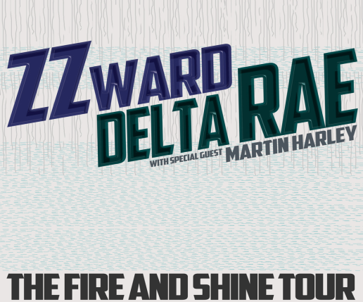

**BURBANK, November 29, 2012** – Acclaimed blues-hop singer ZZ Ward and Delta Rae have announced a co-headlining tour to kick off in Aspen, CO on January 30, 2013. Opening the show will be British slide guitar prodigy, Martin Harley.

Ward’s unique blend of swampy blues and hip-hop has been drawing critical praise since the release of her **Eleven Roses** mixtape and continues with her debut, full-length album, **Til The Casket Drops,**which showcases her songwriting prowess as well as her remarkable voice which *Rolling Stone* called “chill-inducing.” Ward’s unique smoky rasp embodies the blues greats who have inspired her, but it’s the hip-hop flavor that adds a bold freshness to her musical artistry. “Her unapologetic blend of hip-hop, blues and pop paired with smoky vocals could make this singer a star,” exclaimed *USA Today*. After a recent performance on **The Tonight Show with Jay Leno**, her foot-stomping single “Put The Gun Down” shot up the alternative charts at iTunes and Amazon.  Currently in the middle of her first headlining tour, including sold-out dates in Los Angeles, New York City, San Francisco, Denver and Nashville, Ward’s gritty blues-soaked, hip-hop inspired repertoire explodes live as her dynamic vocals captivate with a force prompting the *Chicago Tribune* to declare, “So what are you waiting for? Go hear her.”

The combination of these uniquely dynamic artists will create a live musical experience not to be missed.

A full list of dates is below:

**THE FIRE AND SHINE TOUR 2013**

|  |  |  |
| --- | --- | --- |
| **Date** | **City/State** | **Venue** |
| Wed-Jan-30 | Aspen CO | Belly Up |
| Thu-Jan-31 | Beaver Creek CO | Vilar |
| Sat-Feb-02 | New Orleans, LA | Family Gras |
| Mon-Feb-04 | San Diego, CA | Belly Up |
| Wed-Feb-06 | Los Angeles, CA | Troubadour |
| Thu-Feb-07 | Los Angeles, CA | Troubadour |
| Tue-Feb-12 | Santa Barbara CA | SOHO** |
| Wed-Feb-13 | Santa Cruz CA | Rio Theatre |
| Thu-Feb-14 | San Francisco CA | Great American Music Hall |
| Sat-Feb-16 | Portland, OR | Star Theater |
| Sun-Feb-17 | Seattle  WA | The Crocodile |
| Thur-Feb-21 | Kansas City, MO | The Riot Room |
| Fri-Feb-22 | Minneapolis MN | Triple Rock** |
| Sun-Feb-24 | Chicago IL | Lincoln Hall |
| Mon-Feb-25 | Columbus, OH | The Basement |
| Wed-Feb-27 | Cleveland, OH | Beachland Ballroom |
| Thu-Feb-28 | Toronto, ON | Mod Club |
| Sat - Mar-02 | Boston  MA | Middle East |
| Mon-Mar-04 | Baltimore MD | 8 x 10** |
| Tue-Mar-05 | New York NY | Irving Plaza |
| Wed-Mar-06 | Philadelphia, PA | TLA |
| Fri-Mar-08 | Norfolk, VA | NorVa |
| Sat-Mar-09 | Charlotte, NC | Visulite Theatre |
| Sun-Mar-10 | Nashville TN | 3rd and Lindsley*** |
| Mon-Mar-11 | New Orleans LA | House of Blues *** |

[www.zzward.com](http://www.zzward.com)