For Immediate Release:

ZZ Ward Announces Summer Tour and Festival Run
Two New Tracks Featured on Exclusive Record Store Day 7" Release

Stream 'Grinnin' In Your Face' at Interview Magazine
Stream 'Everybody Wants to Be Famous' at Idolator
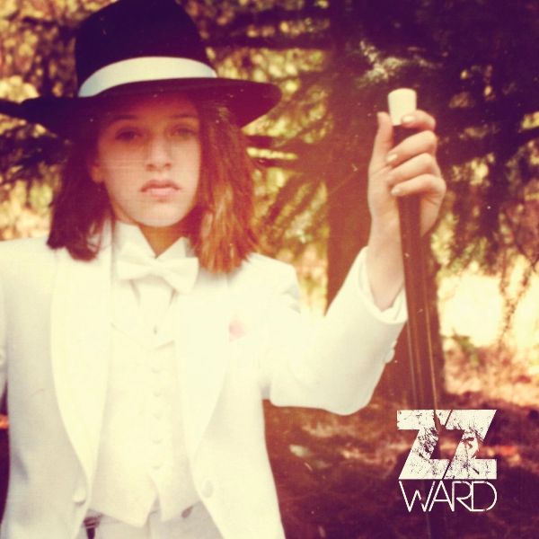

April 17, 2013- Burbank, CA- On the heels of her successful Fire and Shine tour, with sold-out shows in nearly every market, and a buzzworthy return to SXSW, alternative blues-soul singer ZZ Ward has announced her plans for a summer tour and festival run. The tour will kick off in Boise, ID on May 28 and include performances at some of the most anticipated music festivals including Firefly and Sasquatch, where she'll be performing alongside the likes of The Lumineers, Kendrick Lamar, Vampire Weekend, and more. An eclectic and innovative performer, Ward's mix of backporch blues and gritty hip-hop beats has been resonating with both fans and critics alike. Said MTV at a recent SXSW performance, "Instead of a pic of @zzward at @MTV @VH1 @CMT #sxsw showcase, here's the corner I'm crying into because she's so good." Tickets for the tour go on-sale April 20th and a full list of dates is below.

Ward is also is set to make her mark on this year's Record Store Day with an exclusive 7" vinyl (shown above with a vintage photo of ZZ when she's 11 years old), featuring two previously unreleased recordings. On the A-side is a live cut from ZZ's sold-out show at the Troubadour and a cover of Mississippi blues singer and guitarist Son House's song 'Grinnin' in Your Face.' ZZ says about the song, "I enjoy paying homage to my love of the blues when I cover Son House at my shows." Listen to the cover and read an interview with ZZ at Interview Magazine. On the B-side is a song that ZZ says, "makes you want to drive around listening to it on a summer night with the top down," called 'Everybody Wants To Be Famous,' which is an unreleased cut from her album sessions and another collaboration with Neff-U. Listen to the song premiere at Idolator. The exclusive vinyl will be a limited release on this year's Record Store Day, April 20.

Appearances on Good Morning America, The Tonight Show with Jay Leno, Conan, Last Call with Carson Daly and VH1's "Big Morning Buzz Live," keep ZZ in the public eye while her songs continue to be prominently featured in such hits as Nashville, The Voice, ABC Family's Pretty Little Liars and MTV's Awkward.

