** DO NOT REPLY TO THIS EMAIL! REPLY TO: LILLIAN.MATULIC@DISNEY.COM **
FOR IMMEDIATE RELEASE:
SEASON TEN AMERICAN IDOL FINALIST STEFANO SET TO PREMIERE “I’M ON A ROLL” VIDEO EXCLUSIVELY ON VEVO MAY 24
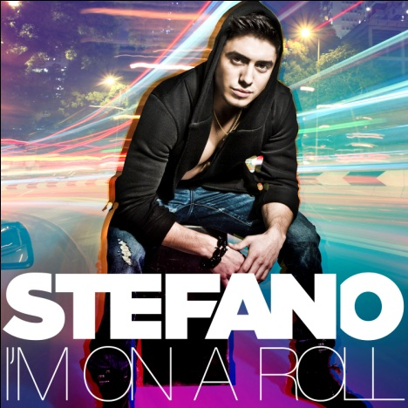
May 23, 2012 – Burbank, CA – On the heels of tonight’s American Idol Finale, Stefano will premiere his video for “I’m On A Roll” exclusively on VEVO, the world’s leading all-premium music video and entertainment platform. The music video was directed by Mickey Finnegan (LMFAO) and filmed at the world famous Hollywood Roosevelt Hotel. The video concept follows the buoyant theme the song showing Stefano having “the best night” of his life.
Stefano performed “I’m On A Roll” on American Idol April 26 and instantly ignited several worldwide Twitter trends, landing a top 25 iTunes debut. Stefano co-wrote “I’m On A Roll” with Tim James, Antonina Armato, and Dennis White, and the track features Ben J from the New Boyz and Rock Mafia (Tim James & Antonina Armato).
Stefano recently completed a three week promotional tour, visiting key radio stations around the country. He won over many new fans with his easy charm and intimate acoustic performances, and the adds are rolling in at Top 40 and Rhythmic stations.
Stefano will return to American Idol tonight for the finale to cheer on the remaining two contestants. Stefano is wrapping up recording his debut album which will be released later this summer.
For a sneak peek behind the scenes of the “I’m On A Roll” video, click on the link below:
http://www.youtube.com/watch?v=O5KLD81HP-8
For More Information on Stefano visit:
http://www.facebook.com/StefanoMusic
http://www.twitter.com/Stefano
http://www.stefanomusic.com

###
Contact:
Lillian Matulic
VP, Publicity
Disney Music Group
Lillian.Matulic@Disney.com

