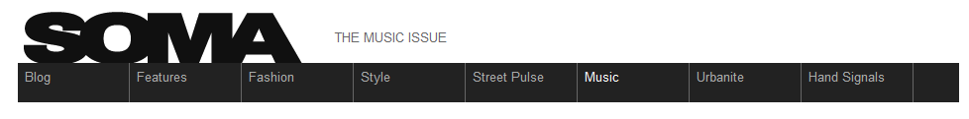
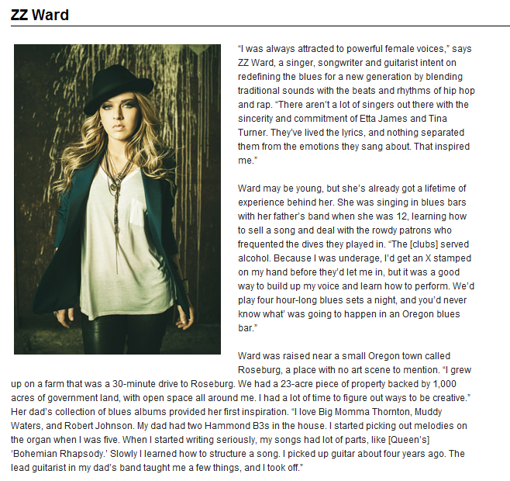
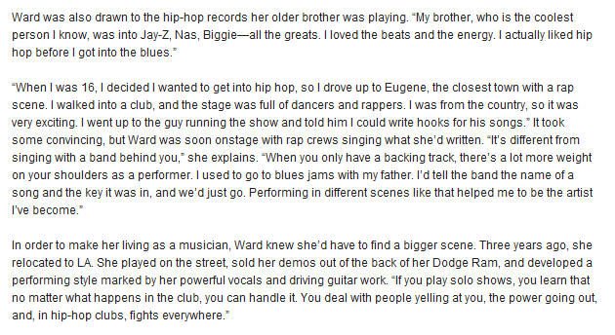
Shortly after arriving in LA, Ward was contacted by the producer and songwriter Evan Bogart, who’d worked with Adam Lambert, Beyoncé, Jennifer Lopez, and Rihanna. “When he called, I thought someone was playing a joke on me,” Ward says. “Then when we met, he asked me to play him a few songs.” Bogart liked what he heard and signed Ward to his new label, Boardwalk Records. They soon started working on her debut album. “[Evan] hooked me up with incredible producers, like Pete Rock, Ali Shaheed Muhammad (A Tribe Called Quest), Blended Babies, and DJ Premier. He didn’t want to change me, so he put me with people who brought out the best in the songs. I’d bring in my GarageBand guitar and vocal demos, and we’d use them as a structure and just have fun. The arrangements happened as we worked together in the studio.”
