FOR IMMEDIATE RELEASE

PLAIN WHITE T’S TO RELEASE SHOULD’VE GONE TO BED DIGITAL EP APRIL 9

BAND TO PERFORM TITLE TRACK ON THE TONIGHT SHOW WITH JAY LENO APRIL 23

PWT’S FOURTH FULL-LENGTH FOR HOLLYWOOD RECORDS DUE LATE SUMMER

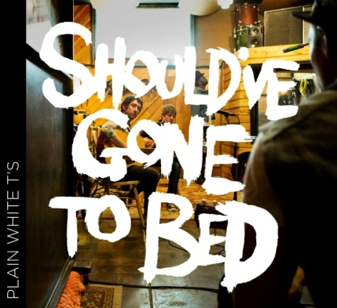
Tim Lopez, Tom Higgenson, Mike Retondo, De’Mar Hamilton, Dave Tirio (photo: James Minchin

April 9, 2013 (Burbank, CA) – Forget everything you think you know about the Plain White T’s. This hard-working band—which began life bashing out Green Day and Weezer covers in a suburban Chicago basement way back in the late ’90s—is in the midst of what may well prove to be a game-changing evolutionary step. Following a three-year stretch on the heels of the release of 2010’s Wonders of the Younger that found the band members evolving as artists and human beings, while experiencing their share of personal tumult and along the way, the veteran rock band returns not just recharged but reborn. The initial proof is in the EP Should’ve Gone to Bed (Hollywood Records, April 9), a preview of the quintet’s fourth album for the label, due this fall. iTunes EP link: http://smarturl.it/pwtiTunesep1

The EP contain two songs apiece from T’s founder/leader/driving force Tom Higgenson and the emerging Tim Lopez, whose dramatic growth as a writer and singer brings an intriguing new dimension to the band, known and beloved for such compelling takes on modern-day romantic entanglements as Higgenson’s “1,2,3,4,” and “Hey There Delilah,” the 2006 chart-topper that put the PWTs on the map, and Lopez’s “Rhythm of Love,” the platinum-plus-selling track that marked the guitarist’s coming of age as a songwriter and lead vocalist.

What these four new tracks (all slotted for the upcoming full-length) have in common are their contoured hooks and immense relatability, as Higgenson and Lopez candidly and colorfully describe situations pulled directly from their personal experiences. Deftly poised between self-mockery and poignancy, Higgenson’s title song and first single recounts what a treacherous and retrospectively humiliating combination too many drinks, a smartphone and an empty bed can be in the aftermath of “striking out again.” Against his better judgment, the song’s narrator dials his ex’s number. “Here I go missing you again,” Higgenson sings ruefully. “God only knows what I said/I should’ve just gone to bed.”

Lopez’s “Haven’t Told Her,” by contrast, zeroes in on the conflicting emotions of exhilaration and anxiety triggered by the blossoming of new love. The song is bookended by the resonant line, “She hit me like a blinding light and I was born.” Promisingly, these two tracks—both produced by Tim Pagnotta (Neon Trees)—rock with more authority than anything the T’s have released to date, with the ace rhythm section of drummer De’Mar Hamilton, bass player Mike Retondo and rhythm guitarist/original band member Dave Tirio bringing the kind of calibrated muscle to these slice-of-life narratives that they display on concert stages.

The next two songs are deeply reflective in nature. Higgenson’s “Helium” (produced by Ian Kirkpatrick, who helmed Wonders of the Younger) ponders mortality—spurred by memories of a near-fatal accident in 2001 in which he was thrown from his van, suffering internal injuries and breaking several vertebrae, and intensified by the deep emotions brought out by becoming a parent—he’s the father of a three-year-old son. The song resolves into a powerful chorus: “So when the day comes/That I don't wake up/I'll float away full of love like helium/From heaven I won't worry/’Cause I left behind one hell of a story.”

Lopez’ metaphorical ballad “Giving Tree” (produced by the renowned Joe Chiccarelli, with additional production by Mudrock) describes a dysfunctional give-and-take relationship—he gives and she takes—by applying the premise of Shel Silverstein’s children’s book of the same title, which Tim remembers being read to him during his formative years. “If all you wanted was love/Why would you use me up/Cut me down, build a boat and sail away?” he sings with palpable feeling. “When all I wanted to be/Was your giving tree/Settle down, build a home and make you happy.”

These are memorable songs indeed, impeccably crafted and shot through with hard-earned self-knowledge. “Personally, I’m in a good place—my head is clearer now,” says Higgenson, recalling the difficulties he’s worked his way through since the last album. “I’m in my 30s now, I’m single and I’m just writing songs about everyday experiences—and that’s what the magic of the Plain White T’s has always been. With a song like “Should’ve Gone to Bed,” it doesn’t get much more real and honest than that. And Tim’s stepping up and writing some great songs.”

As for what may lie ahead for his band, with an album to finish and tour dates to play, Higgenson is philosophical. “All we can do is just do what we do best,” he says, “which is making music.” But having the private life on of the band members exposed is nothing new for the T’s, who have been doing just that in their songs all along.

www.plainwhitets.com
@PlainWhiteTs
iTunes EP link: http://smarturl.it/pwtiTunesep1

Media Contact:
Sharrin Summers
Hollywood Records
818.560.5787 / sharrin.summers@disney.com

0413

