FOR IMMEDIATE RELEASE
MULTIPLATINUM POP-ROCK BAND PLAIN WHITE T’S ANNOUNCE SUMMER TOUR
DATES KICK OFF JUNE 22 IN CHICAGO
ONLINE VIDEO PREMIERE FOR FIRST SINGLE “SHOULD’VE GONE TO BED”
FRIDAY, JUNE 7 AT VH1.COM AND ON-AIR PREMIERE SATURDAY, JUNE 8
DURING VH1 TOP 20 COUNTDOWN
SHOULD’VE GONE TO BED EP OUT NOW; BAND PUTTING FINISHING
TOUCHES ON FULL-LENGTH CD
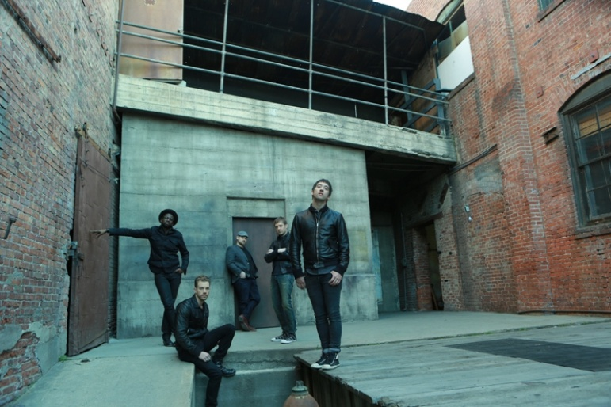
L to R: De’Mar Hamilton, Tim Lopez, Mike Retondo, Dave Tirio, Tom Higgenson (photo credit: James Minchin)
June 6, 2013 - (Burbank, CA) – Two-time Grammy nominated pop-rock quintet Plain White T’s have announced a string of U.S. summer tour dates in support of their new single and EP, Should’ve Gone To Bed. The shows kick off June 22 at the Lincoln Park Zoo in their hometown of Chicago (itinerary below).
"Should’ve Gone To Bed," which the T's recently performed on The Tonight Show with Jay Leno, was written by vocalist/guitarist Tom Higgenson and produced by Tim Pagnotta (Neon Trees). The song recounts what a treacherous and retrospectively humiliating combination too many drinks, a smartphone and an empty bed can be in the aftermath of “striking out again.” Against his better judgment, the song’s narrator dials his ex’s number. “Here I go missing you again,” Higgenson sings ruefully. “God only knows what I said/I should’ve just gone to bed.”
Fans can go to plainwhitets.VH1.com Friday, June 7 for the online exclusive premiere of the official “Should’ve Gone To Bed” video directed by Mike Venezia (“1,2,3,4” and “Rhythm of Love”). And tune in to VH1’s Top 20 Countdown Saturday, June 8 for the broadcast premiere. The band’s previously released meme themed lyric video for the track can be seen here.
The EP also features “Haven’t Told Her," written by vocalist/guitarist Tim Lopez and produced by Pagnotta, as well the Higgenson-penned "Helium," which was recorded with Ian Kirkpatrick, producer of the band's 2010 release, Wonders of the Younger. The disc also features Lopez’s metaphorical ballad “Giving Tree” (produced by the renowned Joe Chiccarelli, with additional production by Mudrock) about a dysfunctional give-and-take relationship (he gives and she takes). Lopez applied the premise of Shel Silverstein’s children’s book of the same title, which he remembers being read to him during his formative years. “If all you wanted was love/Why would you use me up/Cut me down, build a boat and sail away?” he sings with palpable feeling. “When all I wanted to be/Was your giving tree/Settle down, build a home and make you happy.”
In a review of the EP, the New Times wrote, "…the sentimental pop-punk rockers have proved that their intimate, infectious tunes have real staying power.“
Truer words have never been spoken. Over the course of the past few years, Plain White T's have sold over nine million tracks, garnered two Grammy nominations and wrote and recorded three number one radio hits: "Hey There Delilah," "1, 2, 3, 4" and "Rhythm of Love."
The band--rounded out by drummer De’Mar Hamilton, bassist Mike Retondo and rhythm guitarist Dave Tirio--is currently working on a full-length follow-up to Wonders of the Younger. The album is scheduled for a fall 2013 release.
Don't miss your chance to catch Plain White T's live. Visit www.plainwhitets.com for ticketing information.
Dates are as follows:
June 22 | Chicago, IL | Zoo
July 16 | Minneapolis, MN | Varsity Theatre
July 17 | Des Moines, IA | Wooly’s
July 18 | Omaha, NE | The Waiting Room
July 20 | Milwaukee, WI | Festa Italiana
July 22 | St. Louis, MO | Firebird
July 23 | Indianapolis, IN | Deluxe @ Old National Center
July 24 | Cincinnati, OH | 20th Century Theatre
July 26 | Atlantic City, NJ | The Social @ Revel Resort
July 28 | Boston, MA | Paradise Rock Club
July 29 | Washington, DC | 9:30 Club
July 31 | Atlanta, GA | Smith’s Olde Bar
Aug. 1 | New Orleans, LA | House of Blues
Aug. 2 | Austin, TX | The Belmont
Aug. 5 | Colorado Springs, CO | The Black Sheep
Aug. 6 | Denver, CO | Summit Music Hall
Aug. 8 | Ventura, CA | Ventura County Fair
Aug. 9 | Sacramento, CA | Ace of Spades
Aug. 13 | Solana Beach, CA | Belly Up Tavern
Aug. 24 | Lisle, IL | Benedictine University Stadium
Sept. 5 | Salt Lake City, UT | Utah State Fair
Sept. 21 | Grand Prairie, TX | Verizon Theatre at Grand Prairie
Sept. 23 | Yakima, WA | Central Washington State Fair
###
For information contact:
Sharrin Summers - 818-560.5787 / sharrin.summers@disney.com

http://www.plainwhitets.com
https://www.facebook.com/plainwhitets
https://twitter.com/plainwhitets
http://www.youtube.com/user/PlainWhiteTs
http://smarturl.it/pwtiTunesep1
Plain White T's – Should've Gone to Bed – Spotify link

