FOR IMMEDIATE RELEASE:

HOLLYWOOD RECORDS SIGNS “PRETTY LITTLE LIARS” STAR LUCY HALE
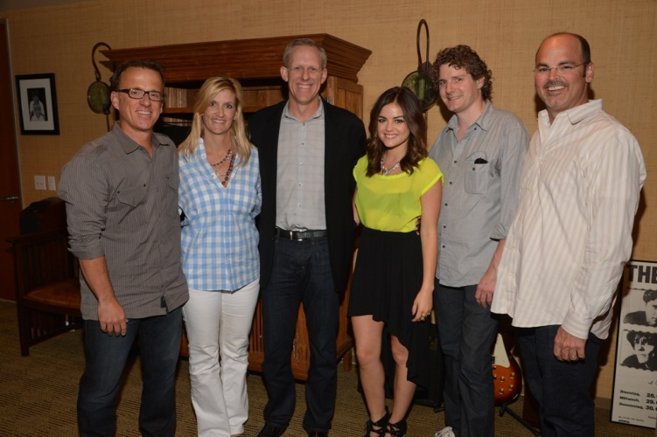
(from left to right-Chip McLean, SVP, Business Affairs/Development, Disney Music Group; Cathleen Taff, SVP/GM, Disney Music Group; Ken Bunt, EVP, Disney Music Group; Lucy Hale; Mike Daly, Director, A&R, Disney Music Group; Robbie Snow, Head of Global Marketing, Hollywood Records)

(June 12, 2012- Burbank, CA) -- Hollywood Records has announced the latest addition to their chart-topping roster with the signing of actress/singer Lucy Hale to an exclusive recording deal. Hale stars in the hit series Pretty Little Liars on ABC Family, currently in its third season airing Tuesday nights at 8/7c. “Lucy’s immense talent and passion for music make her a great fit for the label,” commented Executive Vice President of Disney Music Group, Ken Bunt. “We’re very excited to be working with her.”

A native of Memphis, Tennessee, Hale grew up listening to country music and it still resonates with her today. While she cites Shania Twain and Faith Hill as early influences, it was the Britney Spears “Baby One More Time” video that ignited a serious interest in pursuing music. Hale continued to hone both her musical and acting chops, amassing an impressive credit roll that includes popular TV shows (How I Met Your Mother, The O.C., Privileged) and feature film credits (The Sisterhood of the Traveling Pants 2, Scream 4.)

Performing on Pretty Little Liars and taking the lead in ABC Family’s musical comedy, A Cinderella Story: Once Upon A Song, Hale is ready to revisit her musical roots. "I'm overjoyed and honored to become a member of the Hollywood Records family,“ said Hale, “I've admired the careers they've made and can't wait to see how my musical path is paved out. I'd just like to thank Ken Bunt and everyone involved for giving me the chance to show a whole different side of myself, which is a huge passion for music."

While Hale appreciates all musical genres, it’s her country roots that speak to her heart and will mark the direction of her music. Recording is set to begin later this year with a single and album due in 2013 on Lyric Street/Hollywood Records.

About Disney Music Group
Disney Music Group is home to Hollywood Records, Walt Disney Records, and Disney Music Publishing. The rosters of the record labels span a wide variety of artists including pop (Selena Gomez & The Scene, Demi Lovato, McClain Sisters, American Idol finalist Stefano, Jesse McCartney), rock (Grace Potter & The Nocturnals, Breaking Benjamin, Plain White T’s, Redlight King, Cherri Bomb, ZZ Ward, Bridgit Mendler), and the legendary band Queen, plus family music and soundtracks (Phineas and Ferb, Shake It Up, A.N.T. Farm, Muppets: The Green Album, The Muppets, TRON: Legacy).

Lucy Hale on Twitter: http://twitter.com/lucyyhale
Lucy Hale on Facebook: http://www.facebook.com/LucyHale
###
CONTACT:
Heather Davis, Hollywood Records
Heather.Davis@disney.com
(212) 536-6456

