LUCY HALE DEBUT SINGLE HITS #1 ON ITUNES COUNTRY CHART
VIDEO PULLS IN HALF MILLION VIEWS ON FIRST DAY
Good Morning America performance set for January 10th;
Live With Kelly & Michael January 14th

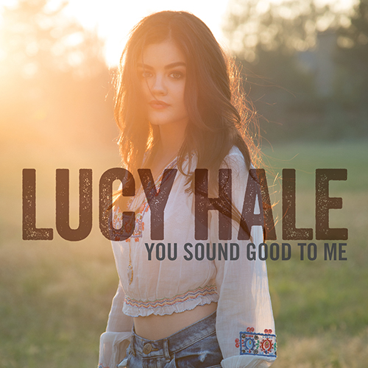

(Nashville, TN) – January 9, 2013 – Yesterday singer/actress, Lucy Hale, released her much-anticipated debut single, “You Sound Good To Me” and the response was palpable. The song shot up the charts landing at #1 on iTunes country chart and #15 overall. USA Today called the song “effervescent” while CMT.com proclaimed, “the actor-turned-singer sounds very legit, very country, and much like a sure thing for country radio.” Written by Nashville tunesmiths Ashley Gorley, Luke Laird and Hillary Lindsey, “You Sound Good To Me” premiered exclusively on SIRIUS XM’s The Highway January 6th and will go wide to country radio next month.
Fans got an extra surprise with an exclusive sneak peak of the video for “You Sound Good To Me” during the winter premiere of the ABC Family hit series, “Pretty Little Liars” on which Hale stars as Aria Montgomery. Directed by Philip Andelman (Taylor Swift, John Mayer, Band of Horses,) the video was shot in California and has already amassed a half million views the first day.
Adding to an already whirlwind week, Hale will make her morning TV debut performing the song for the first time on Good Morning America, Friday, January 10th and Live With Kelly & Michael, January 14th.
Declared an Artist to Watch in 2014 by Shazam and the first USA Today On The Verge pick of the new year, the Memphis born-and-raised 24-year old first started singing along with the radio to her favorite Martina McBride, Faith Hill and Shania Twain songs. While she made her mark early on as an actress, she is eager to share her longtime love for music with her country debut album due this spring on DMG Nashville/Bigger Picture Group.
Learn the latest about Lucy on Facebook and follow her on Twitter and Instagram to find out more about her single, upcoming album and touring plans.
###

For more information regarding Lucy Hale, contact:
Cindy Hunt / Monarch Publicity / 615.429.2203 / Cindy.Hunt@MonarchPublicity.com
Heather Davis / Hollywood Records / 212.536.6456 / Heather.Davis@Disney.com
Nicole Perna / BWR Public Relations / 310.550.7776 / nicole.perna@bwr-pr.com
Leslie Sloane / BWR Public Relations / 212.901.3928 / Leslie.Sloane@BWR-PR.com

