Morning Jam: Start Your Day Right With Grace Potter & The Nocturnals' "Stars"
by Mickey Woods
Tuesday, 08/28/2012
I'm convinced that Grace Potter's been blessed with one of the best voices in rock music today.
Need proof? "Stars," the latest single from the frontwoman and her Nocturnals' dynamic latest album, The Lion The Beast The Beat is here to prove what I'm having trouble describing. It's a simple but potent power ballad about the immediate way you feel after losing someone close to you, which means we all can probably relate. And if you can't, Ms. Grace has got enough soul in her voice and lyrics to help us know what she means. (Listen to the way she emotes the word "stars"--so beautiful!)
A transparent soul translates easily into a smooth-and-steady Morning Jam, I think. Enjoy the official video, below! In monochrome-hued performance style under a starry sky, with Grace in a shimmery gown. Get obsessed!
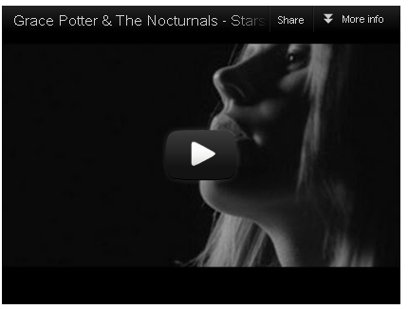
http://www.glamour.com/entertainment/blogs/obsessed/2012/08/morning-jam-start-your-day-rig-24.html

