Music Review

Grace Potter brings energy, sass to House of Blues

By Scott McLennan
| Globe Correspondent
December 03, 2012
http://bostonglobe.com/arts/music/2012/12/03/potter-brings-energy-sass-house-blues/SHVYJlh0Uor98xkP2RHFCK/story.html
- Article

- be
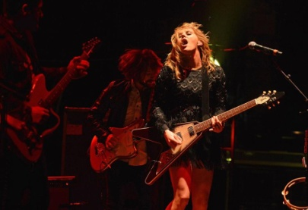Mike Coppola/Getty Images
From dancing barefoot to disco balls, Grace Potter wants it all. On Friday at the first of two sold-out shows at the House of Blues, Potter and her band the Nocturnals bounced between the gritty and the slick in an occasionally disjointed but relentlessly energetic two-hour show.
Potter hasn’t so much transformed as piled on. The hippie-chick crunchiness of her early work still figured into the mix even as she’s taken on a more glamorous look and adopted a more polished sound.
In propping up everything from the synthy, mechanical “Loneliest Soul” to the writhing psychedelic blues of “2:22” (at which point the shoes came off), Potter showcased more vocal muscle than range. The Nocturnals likewise have shed some of their jam-band shag. Guitarist Scott Tournet and drummer Matt Burr spiced a lot of their work with techno flourishes you didn’t hear when these guys were opening for the Black Crowes or playing at the Newport Folk Festival.
The show began with Tournet and fellow guitarist Benny Yurco building a groove with Burr and bassist Michael Libramento that allowed Potter to ride in on the surging wave of “The Lion the Beast the Beat.” With the flash of big-rock-show lights and Potter bounding from keys to flying V guitar, the concert began in high gear and never let up.
Potter and the band took that hard-charging approach into a kitschy rendition of “Some Kind of Ride” and then directed it into the buoyant earnestness of “Ah Mary.”
After the sprawl of “2:22,” Potter seemed to let things loosen a bit. The slow-burn ballad “Stars” led into chunky guitar riffage that set up “Stop the Bus,” a song whose whirlwind seemed to organically blossom rather than arrive in calculated moves.
The two-part “Nothing but the Water” — part one featuring Potter solo with an electric guitar followed by a full-band funk-jam fest — is still a dependable show stopper.
A frenetic cover of the Rolling Stones’ “Paint It Black” closed the regular set. Potter launched her encores with the ballad “Mad Mad River,” inspired by the wrath Hurricane Irene brought to the band’s native Vermont and relevant in the wake of Sandy. Potter wrapped up the show with “Paris (Ooh La La)” and “Medicine,” proving her sass intact.
Progressive bluegrass quintet Trampled by Turtles opened the show with a set that spiked homey musings with occasional blasts of rock ’n’ roll fury.

