For Immediate Release: PUBLICITY

PLAIN WHITE T’S DEBUT VIDEO FOR NEW SINGLE “THE GIVING TREE” ON YOUTUBE

STRIKING VIDEO, FEATURING A “TRANSFORMED” TIM LOPEZ, BY AWARD
WINNING DIRECTOR/CIMEMATOGRAPHER JASON KOENIG (MACKLEMORE & RYAN LEWIS’ “CAN’T HOLD US”)

ON TOUR NOW CO-HEADLINING WITH PARACHUTE

NEW ALBUM, AMERICAN NIGHTS, DUE EARLY 2014
(Advance stream or download of album available upon request)

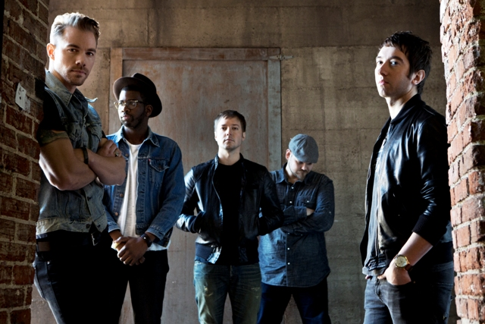
L to R: Tim Lopez, De’Mar Hamilton, Dave Tirio, Mike Retondo, Tom Higgenson
-
November 4, 2013 (Burbank, CA) - Multi-platinum selling band the Plain White T’s released the official video for “The Giving Tree,” the new single from their EP, Should’ve Gone To Bed on YouTube today. “The Give Tree” was directed by award winning director/cinematographer Jason Koenig, best known for Macklemore & Ryan Lewis’ “Can’t Hold Us” and can be viewed HERE.

The song brings an intriguing new dimension to the heartfelt relationship songs upon which the Plain White T’s have built their rabid following, exemplified by the hits “Hey There Delilah,” “Rhythm of Love,” “1, 2, 3, 4” and “Our Time Now,” which have collectively sold more than 10 million tracks.

Leading up to the album’s release, the PWT’s will preview new songs their co-headlining tour with Parachute. Fans can visit www.plainwhitets.com for tour dates and ticketing information.

“The Giving Tree” will also appear on the band’s upcoming album, American Nights, slated for release early 2014. “This is an introspective album about what each of us is going through,” Lopez explains. “After going through painful breakups, one of us is learning how to be single again, and one of us is learning how to be in a relationship again. We’re coming off some interesting experiences: Tom’s relationship ended shortly after his son was born, and after finally getting over a painful divorce, I’ve found love again with someone I met on reality TV, of all things.” Amazon pre-order link HERE.

WATCH AND SHARE THE MUSIC VIDEO:
EMBED LINK:

<iframe width="560" height="315" src="//www.youtube.com/embed/8wGhqtWR4uo" frameborder="0" allowfullscreen></iframe>

TOUR DATES w/PARACHUTE:

Tues., Nov. 5 | Wilmington, DE | World Café Live at The Queen
Thurs., Nov. 7 | Salisbury, MA | Blue Ocean Music Hall
Fri., Nov. 8 | Asbury Park, NJ | The Stone Pony
Sat., Nov. 9 | Westbury, NY | The Space at Westbury
Sun., Nov. 10 | Baltimore, MD | Rams Head Live
Wed., Nov. 13 | Louisville, KY | Headliners Music Hall
Sun., Nov. 17 | Davenport, IA | St. Ambrose University SOLD OUT
Tues., Nov.19 | Sioux Falls, SD | Augustana College
Wed., Nov. 20 | Grand Rapids, MI | The Intersection
Fri., Nov. 22 | Burlington, VT | Higher Ground
Sat., Nov. 23 | Portland, ME | The Asylum

“Should’ve Gone To Be” EP iTunes buy link
http://smarturl.it/pwtiTunesep1

“American Nights” Amazon pre-order:
http://www.amazon.com/gp/product/B00FNDODX4?tag=hollywoodreco-20

For more info on Plain White T’s, visit:
http://www.hollywoodrecords.com/press/plainwhitets/ - Digital media kit
http://www.plainwhitets.com
https://www.facebook.com/plainwhitets
https://twitter.com/plainwhitets
http://www.youtube.com/user/PlainWhiteTs
http://www.youtube.com/watch?v=vxqiRzHBY1k - “Should’ve Gone To Bed” official video

# # #

For media requests contact:
Sharrin Summers
Hollywood Records
818-560.5787 / sharrin.summers@disney.com

