PUBLICITY
FOR IMMEDIATE RELEASE

PLAIN WHITE T’S TO RELEASE “THE GIVING TREE,” THE NEW SINGLE AND VIDEO
FROM THEIR UPCOMING 2014 ALBUM AMERICAN NIGHTS

STRIKING VIDEO, FEATURING A “TRANSFORMED” TIM LOPEZ, BY AWARD
WINNING DIRECTOR/CIMEMATOGRAPHER JASON KOENIG (MACKLEMORE & RYAN LEWIS’ “CAN’T HOLD US”)

VIDEO TO DEBUT ON YOUTUBE NOVEMBER 4

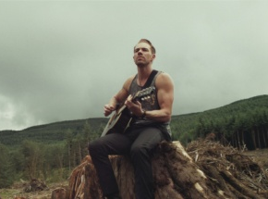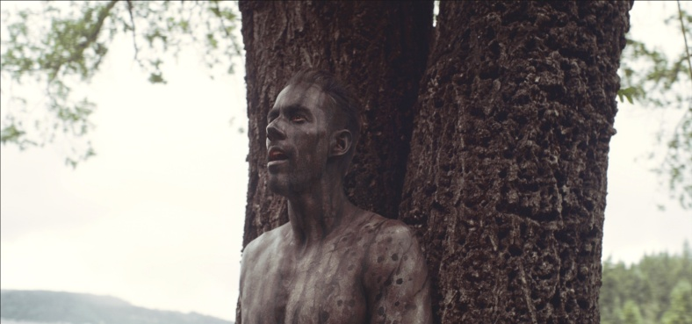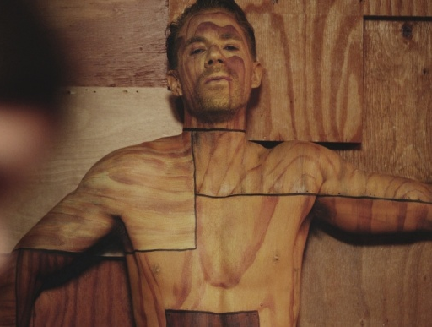

October 14, 2013 (Burbank, CA) - “The Giving Tree,” the new single from the Plain White T’s’ fourth full-length for Hollywood Records, American Nights, will give fans an idea of what they can anticipate from the album hitting in early 2014. The song, written and sung by the band’s Tim Lopez, will be complemented by an inventively conceived and executed video; more about that in a minute. “The Giving Tree” can be heard HERE.

What the 10 songs of American Nights have in common is their immense relatability, as Tom Higgenson and Lopez candidly and intimately describe situations pulled directly from their personal experiences. “This is an introspective album about what each of us is going through,” Lopez explains. “After going through painful breakups, one of us is learning how to be single again, and one of us is learning how to be in a relationship again. We’re coming off some interesting experiences: Tom’s relationship ended shortly after his son was born, and after finally getting over a painful divorce, I’ve found love again with someone I met on reality TV, of all things.” Amazon pre-order link HERE.

“The Giving Tree” brings an intriguing new dimension to the heartfelt relationship songs upon which the Plain White T’s have built their rabid following, exemplified by the hits “Hey There Delilah,” “Rhythm of Love,” “1, 2, 3, 4” and “Our Time Now,” which have collectively sold more than 10 million units. This bittersweet metaphorical ballad describes a dysfunctional give-and-take relationship—he gives and she takes—by applying the premise of Shel Silverstein’s children’s book of the same title, which Tim remembers being read to him during his formative years. “If all you wanted was love/Why would you use me up/Cut me down, build a boat and sail away?” he sings, with palpable feeling. “When all I wanted to be/Was your giving tree/Settle down, build a home and make you happy.”

Lopez felt so strongly about the song that he was going to make and finance his own video. A chance encounter with award winning director/cinematographer Jason Koenig, best known for Macklemore & Ryan Lewis’ “Can’t Hold Us,” took Lopez’s passion project to the next level. After hearing the song and the story behind it, Koenig agreed to shoot the video, and the two set about writing the treatment. Koenig’s cinematography, whose expensive look belies its modest production cost, is stunning and the storyline gripping. The end product resulted in the label backing the video and making the song the next single. Made on sweat and passion, “The Giving Tree” video is an incredible follow-up for the four-time VMA nominated Koenig and it marks his first music video project outside the Macklemore camp.

In the clip, shot on location in the atmospheric locale of Belfair, Washington, the song’s primary metaphor comes vividly to life. Thanks to some painstakingly applied body painting, Tim appears first as the tree of the title and subsequently, after the tree is cut down and repurposed, as part of the wooden wall of a bar. In one of the most unsettling scenes, Lopez in his tree body paint lies motionless on the conveyor belt of a sawmill as it moves him ever closer to the whirring blade that will transform his character into timber.

The intensive three-and-a-half-day shoot was particularly arduous for Lopez, who had to withstand freezing temperatures during countless shoots in his underwear on hardly any sleep, while spending an estimated 25 hours in total having his body painted and repainted. Talk about suffering for your art.

“The Giving Tree” video clip will debut on YouTUBE November 4.

Leading up to the album’s release, the PWTs will hit the road on a November co-headline tour with Parachute.
Visit www.plainwhitets.com for tour dates and ticketing information.
Dates are as follows:
Tues., Nov. 5 | Wilmington, DE | World Café Live at The Queen
Thurs., Nov. 7 | Salisbury, MA | Blue Ocean Music Hall
Fri., Nov. 8 | Asbury Park, NJ | The Stone Pony
Sat., Nov. 9 | Westbury, NY | The Space at Westbury
Sun., Nov. 10 | Baltimore, MD | Rams Head Live
Wed., Nov. 13 | Louisville, KY | Headliners Music Hall
Sun., Nov. 17 | Davenport, IA | St. Ambrose University SOLD OUT
Tues., Nov.19 | Sioux Falls, SD | Augustana College
Wed., Nov. 20 | Grand Rapids, MI | The Intersection
Fri., Nov. 22 | Burlington, VT | Higher Ground
Sat., Nov. 23 | Portland, ME | The Asylum

# # #
Amazon pre-order: http://www.amazon.com/gp/product/B00FNDODX4?tag=hollywoodreco-20

http://www.hollywoodrecords.com/press/plainwhitets/ - digital media kit
http://www.plainwhitets.com
https://www.facebook.com/plainwhitets
https://twitter.com/plainwhitets
http://www.youtube.com/user/PlainWhiteTs
http://www.amazon.com/gp/product/B00FNDODX4?tag=hollywoodreco-20 – album pre-order link
http://smarturl.it/pwtiTunesep1
Plain White T's – Should've Gone to Bed – Spotify link
http://www.youtube.com/watch?v=e7L-2eW46SA – “Should’ve Gone To Bed” lyric video
http://www.youtube.com/watch?v=vxqiRzHBY1k – “Should’ve Gone To Bed” official video

For information contact:
Sharrin Summers
Hollywood Records
818-560.5787 / sharrin.summers@disney.com

