**NO-REPLY EMAIL! CONTACT LILLIAN.MATULIC@DISNEY.COM **
FOR IMMEDIATE RELEASE:
ZENDAYA SET TO RELEASE FIRST SINGLE “REPLAY” JULY 16 ON HOLLYWOOD RECORDS
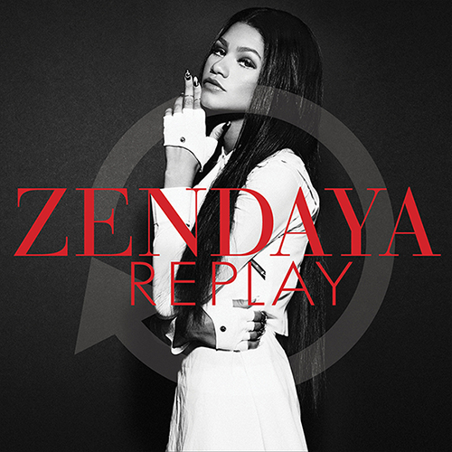
June 27, 2013 – (Burbank, CA) Zendaya is set to release her first single, “Replay,” July 16 (insert URLs). Produced by Mick Shuultz (Jeremih) and written by Tiffany Fred (Jason Derulo, Jennifer Hudson) & Paul “Phamous” Shelton (Frank Ocean), “Replay” is a rhythmic pop jam that highlights Zendaya’s smooth as silk vocals, on par with several of today’s top pop and R&B divas. Zendaya recently shot her music video for “Replay” with award winning music video director Colin Tilley (Justin Timberlake, Chris Brown, Usher) and choreographer Ian Eastwood. Premiere plans for the music video will be announced shortly.
Prior to the “Replay” single release, Zendaya will premiere the song on Radio Disney July 12 at 4pm Pacific/7pm Eastern.
Zendaya is an impressive talent, known for her singing, dancing and acting skills, as well as for her unique and trend-setting sense of style. Zendaya stars in the Disney Channel series “Shake It Up” which has aired in 164 countries and reached over 150 million viewers world-wide. Three soundtracks have been released from “Shake It Up” featuring Zendaya. The singles from the “Shake It Up” soundtracks have netted over 110 million online video views and combined track sales of over two million. Zendaya appeared this past spring on the hit ABC show “Dancing With The Stars” which is seen in over 13 million households. Zendaya scored perfect and nearly perfect scores each week and finished in second place. Zendaya has graced many magazine covers and was featured in the TV commercial for Beats by Dre. Come August 6, she will be a published author as well with her upcoming book, “In Between U and Me: How to Rock Your Tween Years with Style and Confidence.”
This Friday, Zendaya will be co-hosting BET’s “106th & Park” during the BET Experience leading up to the BET Awards on Sunday.
This summer Zendaya will be doing a number of fair dates and other promotional appearances before her album debut early this fall.
June 30 | Taste of Chicago | Joliet, IL
July 5 | Marin County Fair | San Raphael, CA
July 6 | Alameda County Fair | Pleasanton, CA
July 14 | Saratoga Race Track | Saratoga Springs, NY
July 27 | California State Fair | Sacramento, CA
August 24 | New York State Fair | Syracuse, NY
August 25 | Family Channel Big Ticket Summer Concert | Toronto, CANADA
September 20 | Kern County Fair | Bakersfield, CA
September 21 | Los Angeles County Fair | Pomona, CA
October 1 | Tulsa State Fair | Tulsa, OK
October 12 | Fresno Fair | Fresno, CA

For More Info on Zendaya, visit:
facebook.com/zendaya
twitter.com/zendaya
instagram.com/zendayamaree
zendaya.com
# # #

Contact:
Lillian Matulic
VP, Publicity
Disney Music Group
Lillian.Matulic@Disney.com

Meghan Prophet
PMK
Meghan.Prophet@pmkbnc.com

Michael Gagliardo
PMK
Michael.Gagliardo@pmkbnc.com

