FOR IMMEDIATE RELEASE:
ZENDAYA SET TO RELEASE SELF-TITLED DEBUT ALBUM SEPTEMBER 17
Rising Star chosen for VEVO LIFT program
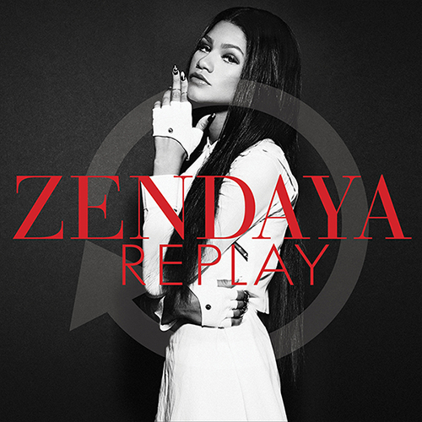
(Burbank, CA) – Hollywood Records recording artist Zendaya is set to release her self-titled debut album September 17. Zendaya worked with an a-list team of producers and writers, including Mick Schultz, Harmony Samuels, Jonas Jeberg, The Suspex, Jukebox, The Monsters and The Strangerz, and Livvi Franc. The album is now available for pre-order on Amazon.com at http://smarturl.it/zAmazona1, and also will be available for pre-order on iTunes August 20 at http://smarturl.it/ziTunesa1.
Zendaya’s “Replay” video premiered August 15 on VEVO and the Disney Channel, and garnered over 4 million views in four days leading to an astounding 500% increase in single sales. Directed by award winning music video director Colin Tilley (Justin Timberlake, Chris Brown), Zendaya worked with choreographer Ian Eastwood to create the ultimate dance jam. Zendaya has also been selected for LIFT, VEVO's emerging artists program. LIFT kicked off August 16, giving fans the opportunity to get to know Zendaya through video premieres, exclusive interviews, behind-the-scenes footage, and more at www.vevo.com/lift. The 8 week LIFT program will highlight live performances and feature an exciting look in the studio on how her debut album was created.
Zendaya is already a formidable force online with millions following her socials, including 3 million on Facebook, 3.3 million on Twitter, 2.1 million on Instagram and over 135 million views on her videos on VEVO. Zendaya stars in the Disney Channel Original Series “Shake It Up” which has aired in 164 countries and reached over 150 million viewers worldwide. Zendaya impressed judges and fans alike on ABC’s “Dancing With The Stars” this spring, reaching nearly 13 million households every week. Zendaya was featured on three soundtracks from the “Shake It Up” series with combined sales of nearly 1 million. Later this summer she’ll be releasing her first book, “Between Me & You” on Hyperion.
Zendaya has several tour dates coming up.
August 24 | Syracuse, NY | New York State Fair
August 25 | Toronto, ONT | Family Channel Event
September 20 | Bakersfield, CA | Kern County Fair
September 21 | Pomona, CA | Los Angeles County Fair
October 1 | Tulsa, OK | Tulsa State Fair
October 12 | Fresno, CA | Fresno Fair
October 25 | Phoenix, AZ | Arizona State Fair
About Disney Music Group:
Disney Music Group is home to Hollywood Records, Walt Disney Records, and Disney Music Publishing. The labels’ genre-spanning rosters include Selena Gomez, Demi Lovato, Grace Potter & The Nocturnals, Lucy Hale, American Idol finalist Stefano, Coco Jones, R5, Bridgit Mendler, Plain White T’s, Redlight King, ZZ Ward, and more. DMG also releases family music and film and television soundtracks such as the Grammy nominated soundtracks for The Muppets and Brave, Avengers Assemble, Phineas and Ferb, A.N.T. Farm, Shake It Up, and Wreck-It Ralph.
About VEVO:
About VEVO VEVO is the world’s leading all-premium music video and entertainment platform. VEVO is available in the United States, Australia, Brazil, Canada, France, Ireland, Italy, The Netherlands, New Zealand, Poland, Spain and United Kingdom through VEVO.com, the mobile web, Mobile and Tablet Apps (iPhone, iPad, Android, Windows Phone, Windows 8, Kindle Fire), Connected Television (Xbox, Roku, Boxee) and user embeddable video players. VEVO TV, an always-on broadcast-style music and video channel, is also available in the US and Canada within VEVO.com and apps for iOS, Android, Windows Phone, Windows 8, Kindle Fire, Xbox and Roku. In various territories, VEVO powers music videos on artist pages across Facebook, as well as syndicates to dozens of online sites, including AOL, BET, CBS Interactive Music Group (including Last.fm, Metro Lyrics and MP3.com), Disney Interactive, Fuse.tv, Univision, Viacom Media Networks, Wenner Media and Yahoo! Music. Additionally, through a special partnership with YouTube, VEVO is accessible in over 200 markets, expanding the platform’s reach around the globe.
For more info on Zendaya, visit:
facebook.com/zendaya twitter.com/zendaya instagram.com/zendayamaree
zendaya.com Official “Replay” teaser video: http://www.youtube.com/watch?v=YBaUwl_wVI4

# # #
Contact:
Lillian Matulic, VP, Publicity - Disney Music Group Lillian.Matulic@Disney.com
Meghan Prophet, PMK, Meghan.Prophet@pmkbnc.com
Michael Gagliardo, PMK, Michael.Gagliardo@pmkbnc.com

